NAME : Allahdad

CMS-ID : 23-22-0109

INSTRUCTOR : Sir Asif Ali

Lab 6

**Exercise 1**

class Inheritance{

public static void main(String args[]){

Employee emp = new Employee("Aadil Shah", "Intermediate", 'A');

Teacher teacher = new Teacher("M Ali", "2nd Year", 'B',87,98);

Professor prof = new Professor("Waseem", "3rd Year", 'A',5,6);

System.out.println("=============Main Class===============");

System.out.println("======Employee Info : ========");

emp.Intro();

System.out.println("======Teacher Info : ========");

teacher.Intro();

teacher.teaching();

System.out.println("======Professor Info : ========");

prof.Intro();

prof.ResearchPublication();

prof.experience();

}

}

class Employee{

String name;

String qualification;

char grade;

Employee(String name,String qual,char grade){

this.name = name ;

this.qualification = qual ;

this.grade = grade ;

}

void Intro(){

System.out.println("Name : "+this.name);

System.out.println("Qualification : "+this.qualification);

System.out.println("Grade : "+this.grade);

}

}

class Teacher extends Employee{

int eng , maths;

Teacher(String name , String qual, char grade,int eng, int maths){

super (name,qual,grade);

this.eng = eng;

this.maths = maths;

}

void teaching(){

System.out.println("Eng : "+this.eng);

System.out.println("Maths : "+this.maths);

}

}

class Professor extends Employee{

int experience = 5 ;

int NoOfPublications = 6;

Professor(String name , String qual, char grade,int exp, int Noofpub){

super (name,qual,grade);

this.experience = exp;

this.NoOfPublications = Noofpub;

}

void ResearchPublication(){

System.out.println("Number of publications : "+this.NoOfPublications);

}

void experience(){

System.out.println("Number of Experience : " + this.experience );

}

}

**Exercise 2**

class Inheritance{

public static void main(String args[]){

Student stu = new Student("Aadil Shah", "023-20-0106", 2020);

BSStudent bsstu = new BSStudent("M Ali", "023-21-0108", 2021,3.9);

MSStudent msstu = new MSStudent("Waseem", "023-22-0111", 2022,3.9,"MS - CS",9);

System.out.println("=============Main Class===============");

System.out.println("======Student Info : ========");

stu.display();

System.out.println("======BSStudent Info : ========");

bsstu.display();

bsstu.award();

System.out.println("======MSStudent Info : ========");

msstu.display();

msstu.award();

msstu.Publication();

}

}

class Student{

String name;

String id;

int year;

Student(String name,String id, int year){

this.name = name ;

this.id = id ;

this.year = year ;

}

void display(){

System.out.println("Name : "+this.name);

System.out.println("Id : "+this.id);

System.out.println("Year : "+this.year);

}

}

class BSStudent extends Student{

double gpa;

String award="10 crore";

BSStudent(String name,String id, int year,double gpa){

super (name,id,year);

this.gpa = gpa;

}

void award(){

System.out.println("GPA : " + this.gpa);

System.out.println("Award : "+this.award);

}

}

class MSStudent extends BSStudent{

String specialization;

int NoOfPublications = 6;

MSStudent(String name,String id, int year,double gpa,String sp,int Noofpub){

super (name,id,year,gpa);

this.specialization = sp;

this.NoOfPublications = Noofpub;

}

void Publication(){

System.out.println("Number of publications : "+this.NoOfPublications);

}

}

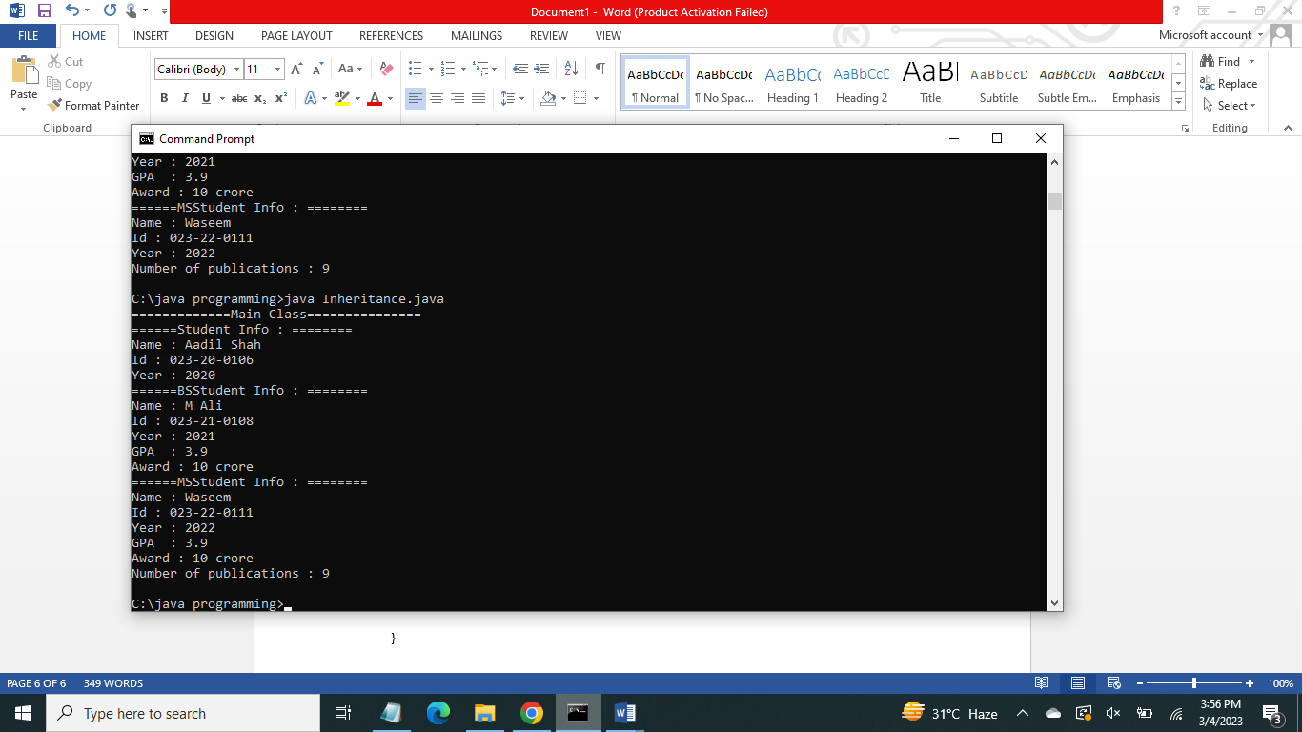

**Exercise 3**

class MAIN2{

public static void main(String args[]){

Library obj1 = new Library(30,"Programming books");

Library obj2 = new Library(50,"Sub-continent History");

Department ob1 = new Department("Computer System Engineering","Engineering","Umar Jaan");

Department ob2 = new Department("Computer Science","Science","Aadil Shah");

ob1.uniDetails();

ob1.departmentDetails();

ob2.departmentDetails();

obj1.libraryDetails();

obj2.libraryDetails();

}

}

class University{

String name = "Sukkur IBA University";

int rankNo = 50 ;

void uniDetails(){

System.out.println("=========University Details=========");

System.out.println("Name : "+this.name);

System.out.println("Rank : "+this.rankNo);

}

}

class Department extends University{

String field_specialization;

String field_type;

String HOD;

Department(String fs, String ft, String hod){

this.field_specialization = fs;

this.field_type = ft;

this.HOD = hod;

}

void departmentDetails(){

System.out.println("=========Department Details=========");

System.out.println("Field Specialization : "+this.field_specialization);

System.out.println("Field Type : "+this.field_type);

System.out.println("Head of Department : "+this.HOD);

}

}

class Library extends University{

int no_books;

String type_books;

Library(int booksNo, String booksType){

this.no_books = booksNo ;

this.type_books = booksType;

}

void libraryDetails(){

System.out.println("=========Library Details=========");

System.out.println("Number of Books : " + this.no_books);

System.out.println("Type of Books : "+this.type_books);

}

}

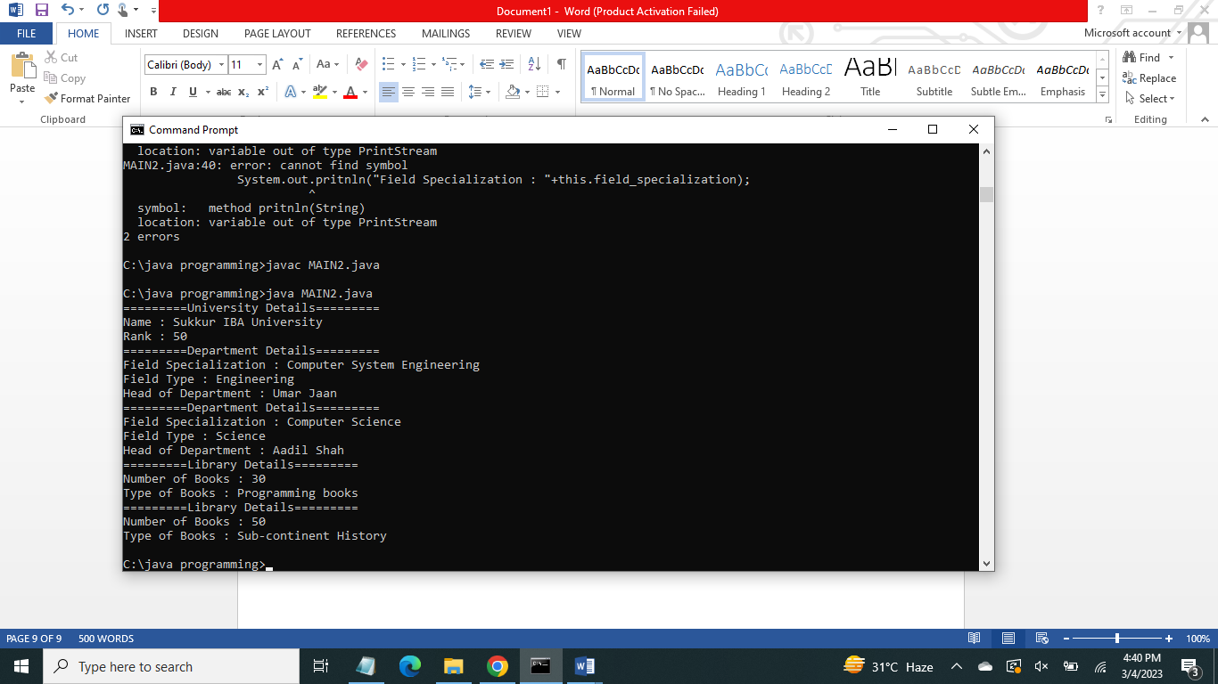

**Exercise 4**

class main3{

public static void main(String args[]){

SuperClass ob = new SuperClass("Aadil");

SubClass obj = new SubClass("Mr.Shah");

System.out.println(ob.Info());

System.out.println(obj.Info());

}

}

class SuperClass{

String name;

SuperClass(String name){

this.name = name;

}

String Info(){

return this.name;

}

}

class SubClass extends SuperClass{

String name;

SubClass(String name){

super(name);

this.name = name;

}

String Info(){

return this.name;

}

}

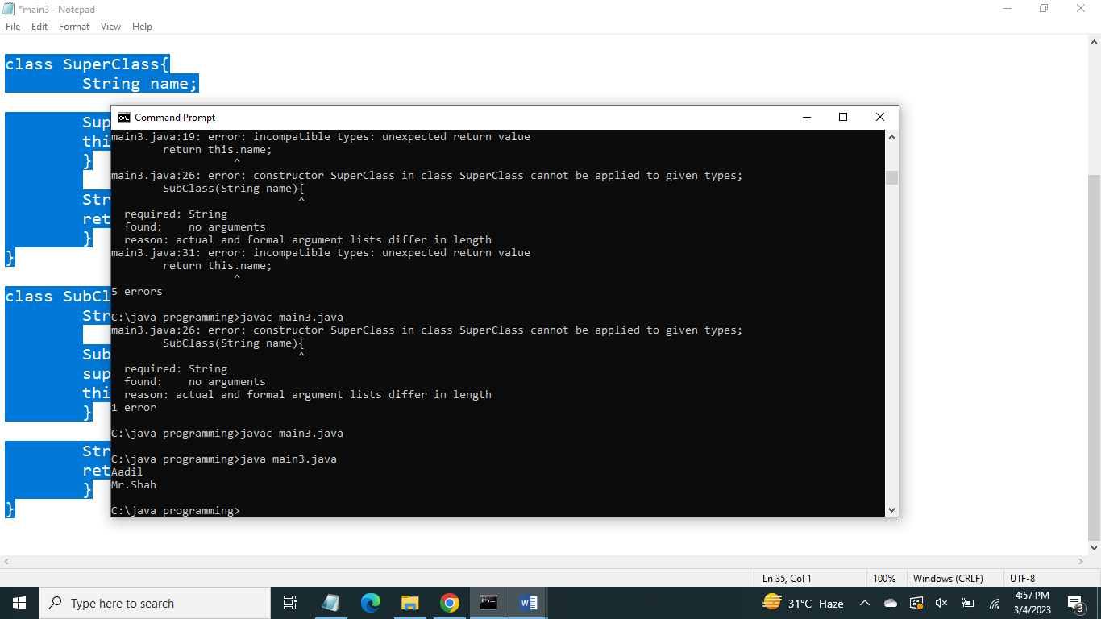

**POST LAB QUESTIONS TO PONDER**

**Can class extend more than one classes?If yes, give reason**

No, one class cannot be extended from more than one classes.

**What is difference between composition and aggregation?**

Association between two objects that illustrate the “has-a” relationship is called Aggregation. A composition defines a part-of a relationship, and both the entities are connected to each other.

**Can you restrict a class from inheriting another class?**

Yes, by using ‘final’ keyword in the starting of a class.

**Can we access private instances in derived classe?**

No we can not access private instances of a superclass from derived class.

**What is difference between this and super keyword?**

This keyword is used to access the instance members of the same class whereas super keyword is used to access superclass instance variables as well as to invoke superclass constructor.

**Why multiple level inheritance is not allowed in Java?**

Java doesn't support multiple inheritances in classes because it can lead to diamond problem.

And also java compiler cannot take right decisions when facing multiple level inheritance.